Supplementary Materials for

Neurocultural Evidence That Ideal Affect Match Promotes Giving

BoKyung Park, Elizabeth Blevins, Brian Knutson, Jeanne L. Tsai.

correspondence to: jltsai@stanford.edu or jeanne.tsai@stanford.edu

Section 1. Sample facial stimuli and FaceGen parameters
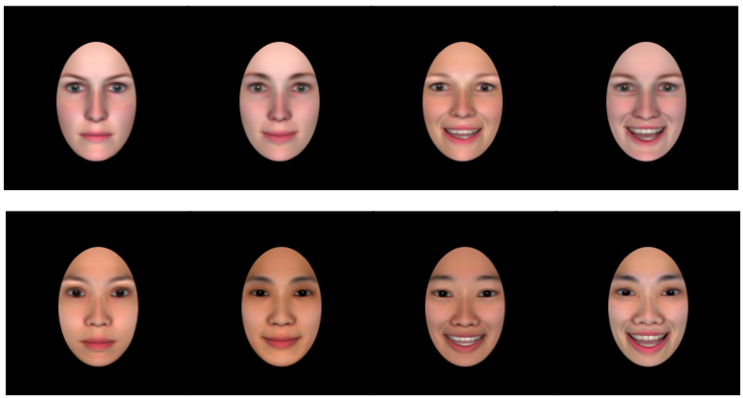
Expression  Intensity | Neutral  (no smile) | Calm  (low) | Moderately Excited  (moderate) | Excited  (high)
SmileClosed | 0 | 0.50 | 0.57 | 0.60
SmileOpen | 0 | 0 | 0.75 | 1.00
EyeSquint Left | 0 | 0 | 0.15 | 0.20
EyeSquint Right | 0 | 0 | 0.15 | 0.20
Phoneme:aah | 0 | 0 | 0.45 | 0.50
Phoneme:big aah | 0 | 0 | 0 | 0.10
Phoneme: D, S, T | 0 | 0 | 0.45 | 0.50

Top two rows: Sample White and Asian female faces. In Study 1 (behavior only), we used neutral, calm, and excited faces. In Study 2 (neuroimaging), we used all 4 expressions, and binned them into two categories: (1) “calm expressions” (by aggregating responses to no and low intensity smiles) and (2) “excited expressions” (by aggregating responses to moderate and high intensity smiles, as in (Park, Tsai, Chim, Blevins, & Knutson, 2016).
Section 2. Cultural differences in offers to excited, calm, and neutral recipients

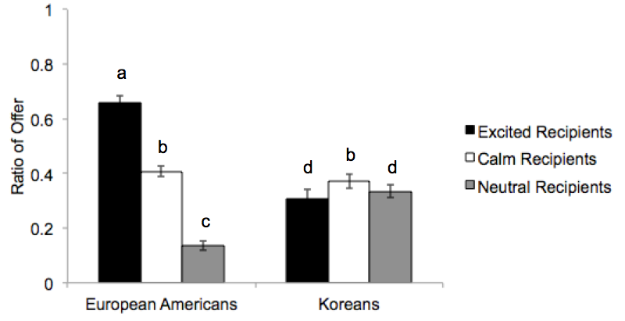
In order to examine offers to neutral faces, we conducted a 2 Participant Culture (European American, Korean) X 3 Recipient Expression (excited, calm, neutral) X 2 Recipient Race (White, Asian) X 2 Recipient Sex (male, female) X 2 Amount of Endowment ($14, $6) repeated-measures ANOVA on the ratio of money offered. There was a significant main effect of Participant Culture, F(1,152) = 3.92, p = .050, such that European Americans (M [S.E.] = .40 [.02]) offered marginally more than did Koreans (M [S.E.] = .34 [.03]) in general, consistent with previous findings that individualism enhances overall giving (Kemmelmeier, 2006). There was also a significant main effect of Recipient Expression, F(2,304) = 148.28, p < .001, with participants offering the most to excited recipients (M [S.E.] = .48 [.02]), followed by calm recipients (M [S.E.] = .39 [.02]), and the least to neutral recipients overall (M [S.E.] = .24 [0.02]), all ps < .001. However, these main effects were qualified by a significant Participant Culture by Recipient Expression interaction, F(2,304) = 183.07, p < .001. European Americans offered significantly more to excited recipients than Koreans, p < .001. European Americans and Koreans did not differ in their offer to calm recipients, p = .270. However, Koreans offered significantly more to neutral recipients than did European Americans, p <.001. European Americans offered significantly more to excited recipients (M [S.E.] = .66 [.03]) than calm recipients (M [S.E.] = .41 [.02]) or neutral recipients (M [S.E.] = .14 [.02]). They also offered significantly more to calm recipients than neutral recipients, all ps < .001, showing a linear increase in offer with increasing intensity of smiles. In contrast, Koreans offered more to calm recipients (M [S.E.] = .37 [.03]) than excited (M [S.E.] = .31 [.04]), p = .001, and neutral recipients (M = .34 [.02]), p = 0.021. Koreans did not differentiate between excited and neutral recipients, p = .359. Different letters indicate significant differences, ps < .05.

Section 3. Cultural differences in avatar selection
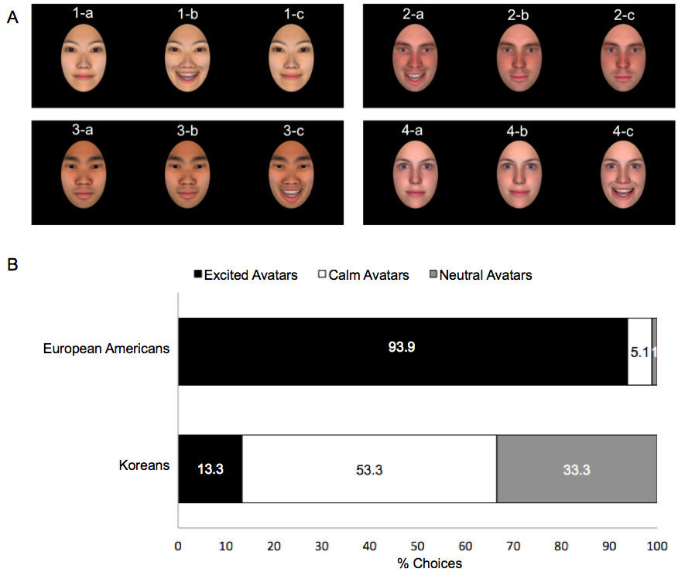
European Americans selected excited avatars (93.9%) more often than calm (5.1%) or neutral (1.0%) avatars. Koreans selected calm (53.3%) avatars more often than excited (13.3%) or neutral (33.3%) avatars, $χ^{2}$(df = 2) = 105.19, p < .001. Participants chose avatars of the same sex as themselves: male participants primarily selected male avatars (88.9%) and female participants primarily chose female avatars (62.5%), $χ^{2}$(df = 1) = 41.20, p < .001. There were no cultural differences in selection of White or Asian avatars, $χ^{2}$(df = 1) = .01, p = .925, suggesting that match in emotional expression and sex mattered more than race in avatar selection. An ordinal regression model with participants’ ideal affect (High-arousal positive states [HAP] – Low-arousal positive states [LAP]) and participants’ actual affect (HAP – LAP) on avatar selections revealed that the more participants valued HAP over LAP, the more likely they were to choose avatars with higher intensity smiles, Estimate (S.E.) = 1.34 (0.26), p < .001. Participants’ actual affect (HAP – LAP) was not related to their avatar selections, Estimate (S.E.) = -0.10 (0.26), p = .718.

Section 4. Cultural differences in mean-deviated ratio of offers and trustworthiness ratings

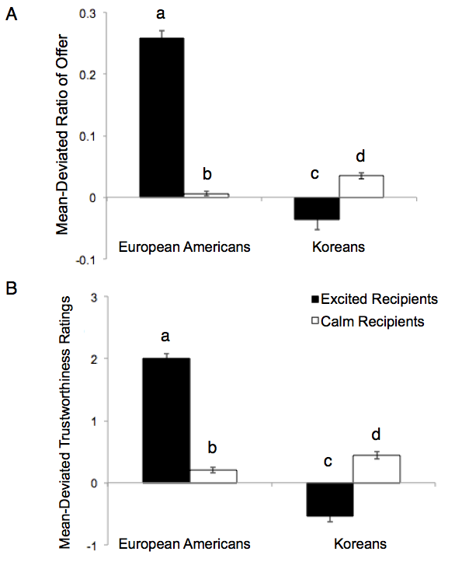
(A) Mean-deviated offer: Based on mean-deviated ratio of offers, European Americans offered more to excited recipients than their Korean counterparts, whereas Koreans offered more to calm recipients than European Americans. European Americans offered more to excited vs. calm recipients, while Koreans offered more to calm vs. excited recipients. (B) Mean-deviated trustworthiness ratings: Based on mean-deviated trustworthiness ratings, European Americans perceived excited recipients as more trustworthy than did their Korean counterparts, whereas Koreans perceived calm recipients as more trustworthy than did European Americans. European Americans rated excited recipients as more trustworthy than calm recipients, while Koreans rated calm recipients as more trustworthy than excited recipients. Different letters indicate significant differences, ps < .005.

Section 5. Indirect effects of other trait ratings
Indirect effects of perceived friendliness, assertiveness, dominance, intelligence, and financial neediness of recipients on offers in Study 1. As shown below, none of these traits mediated cultural differences in offer to excited vs. calm recipients.
 | Standardized Indirect Effect (S.E.) | 95% Confidence Interval
Friendliness | .0167 (.0218) | [-.0203, .0663]
Assertiveness | .0040 (.0129) | [-.0101, .0414]
Dominance | -.0002 (.0066) | [-.0157, .0125]
Intelligence | .0182 (.0153) | [-.0041, .0596]
Financial neediness | .0061 (.0081) | [-.0027, .0334]

Section 6. Dictator game with more realistic facial stimuli
Materials and Methods
Participants
Sixty-three American students (65.1% female) from Stanford University and 63 South Korean students (58.7% female) from Seoul National University were recruited for an on-line study on personal memory and decision-making. Participants received an $8 or 8,000 Korean won gift card as compensation for participating in the study.
To ensure that participants represented the cultures of interest, European American participants were required to have been born and raised in the U.S., and have parents who were born and raised in North America (US or Canada). Korean participants were required to have been born in Korea, and have parents who were born and raised in Korea. Moreover, we excluded participants who did not vary their responses during the Dictator Game to maintain consistency with the fMRI study (see Study 2 for rationale), resulting in a final sample size of 32 European Americans and 55 Koreans.
The groups differed in age, t(85) = -2.93, p = .004 (European American Mean = 20.94, SD = 2.50; Korean Mean = 23.05, S.D. = 3.62), family income level, t(85) = 2.63, p = .010 (1 = less than $10,000, 2 = $10,001-$20,000, 3=$20,001-$30,000, 4=$30,001-$40,000, 5=$40,001-$50,000, 6=$50,001-$75,000, 7=$75,001-$100,000, 8=over $100,000; European American Mean = 6.34, S.D. = 1.84; Korean Mean = 5.29, S.D. = 1.78), and socioeconomic status, t(85) = 2.51, p = .014 (1 = lower income, 2 = lower middle income, 3 = middle income, 4 = upper middle income, 5 = upper income; European American Mean = 2.91, S.D. = 1.97; Korean Mean = 2.02, S.D. = 1.33). Results did not change when these variables were entered as covariates in our analyses, and therefore, we do not discuss them further.
Facial Stimuli
Because there were no existing databases with sufficient numbers of White and Asian real faces with the emotional expressions of interest, we created a set of standardized facial stimuli. We used images from the IAS Lab Face Set (Barrett & Bliss-Moreau, 2009) for White targets, and images from the Taiwanese Facial Expression Database (Chen & Yen, 2007) for Asian targets. From each image database, we imported 8 excited (IAS Lab Face set; happy-straight gaze-open mouth faces, Taiwanese; high-intensity happy faces) faces, 8 calm faces (IAS Lab Face set; happy-straight gaze-closed mouth faces, Taiwanese; low-intensity happy faces), and 8 neutral faces (50% White, 50% female) into Facegen Modeller program (http://facegen.com) and edited these images in Adobe Photoshop Elements to standardize the target’s head position and eye level. Additionally, we applied a black mask (474 X 370 pixels) to control the image background.
Participants viewed 12 total faces: 4 excited, 4 calm, and 4 neutral (see sample faces in Section 4, Figure S4A) that were matched by participant sex (e.g., male participants always viewed male faces). Excited and calm expressions of a particular target were counterbalanced across participants, as was the presentation order of the faces.
Dictator Game
Participants played 12 trials of the game on-line, each with a different recipient. At the beginning of each trial, participants were given an endowment of $6 or $14, and could offer from $0 to $6 or from $0 to $14 in one-dollar increments on any given trial.
Procedure
Participants were recruited on-line. At the beginning of the study, participants were told that they would: (1) participate in a game that had two players, (2) be randomly assigned to one of the two roles in the game, a “proposer” or a “recipient,” and (3) play this game with several different players. Proposers would receive a certain amount of money, which they could then offer to the recipients. Participants were instructed that proposers could give all of the money (i.e., keep none of it), give none of the money (i.e., keep all of it), or give a proportion of the money (i.e., keep some of it). Recipients, in contrast, had no choice but to accept the offer from proposers.
Participants were then told that they would play the game as the “proposer,” and that they would see edited photos of the recipients with whom they were playing. In order to make participants believe that the recipients were actual people, we told participants that the recipients were previous study participants and that they, too, could be recipients in future games if they uploaded a photo of themselves at the end of the study (in actuality, participants were not given this opportunity). Participants were also informed that one of the trials would be randomly chosen to count for “real,” as in the previous study, and that they would be given the amount of money they kept for themselves on that selected trial.
Participants played the game with 12 different recipients. After completing the game, participants viewed the recipients’ faces again and rated each recipient in terms of trustworthiness, along with other traits. Afterwards, participants completed a demographic survey and received the amount of money they kept on the randomly selected trial in addition to their study compensation. Because this study was part of a larger study aimed at manipulating ideal affect, we did not measure participants’ ideal and actual affect. All materials, instructions, and measurements were translated and back-translated into Korean by two independent translators. All procedures were approved by the Stanford institutional review board.
Data Analyses and Results
Analyses of Ratio of Offer. We conducted a 2 Participant Culture (European American, Korean) X 2 Participant Sex (male, female) X 2 Recipient Expression (Excited, Calm) X 2 Recipient Race (White, Asian) X 2 Amount of Endowment ($14, $6) repeated-measures analysis of variance (ANOVA) on ratio of offer. Participant Culture and Participant Sex were between-subjects factors, and Recipient Expression, Recipient Race, and Amount of Endowment were within-subjects factors. See Figure S4B for results.
Analyses of Perceived Trustworthiness. We conducted 2 Participant Culture (European American, Korean) X 2 Participant Sex (male, female) X 2 Recipient Expression (Excited, Calm) X 2 Recipient Race (White, Asian) repeated-measures analysis of variance (ANOVA) on trustworthiness ratings. Participant Culture and Participant Sex were between-subjects factors, and Recipient Expression and Recipient Race were within-subjects factors (see Figure S4C for results).
Indirect Effect. To examine whether trustworthiness ratings mediated cultural differences in offers to excited vs. calm recipients, we again created difference scores in which we subtracted trustworthiness ratings for calm recipients from those of excited recipients, and we subtracted the mean ratio of offers to calm recipients from those made to excited recipients. We then conducted indirect effect analyses (Preacher & Hayes, 2008) with 1000 bootstrapped samples.

Figure S6. Results of dictator game with realistic facial stimuli
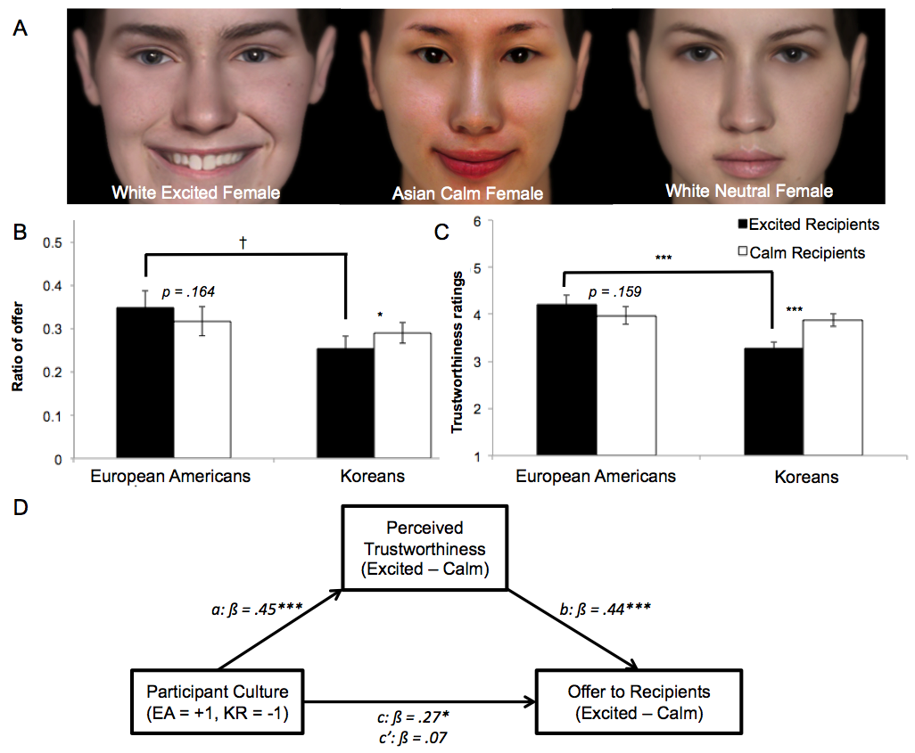
We replicated cultural differences in offers to excited and calm recipients, and in trustworthiness of excited and calm recipients using the same dictator game paradigm with more realistic faces. (A) Examples of realistic facial stimuli: From left to right, White excited female, Asian calm female, White neutral female faces. Neutral faces were fillers. (B) Cultural differences in offer to realistic excited and calm recipients: A significant Participant Culture X Recipient Expression interaction, F(1,83) = 6.52, p = .012, revealed that European Americans offered more to excited recipients than did their Korean counterparts, p = .060. Koreans offered more to calm recipients than excited recipients, p = .016. These findings held across recipient race and sex. (C) Cultural differences in perceived trustworthiness of excited and calm recipients: A significant Participant Culture X Target Expression interaction, F(1,82) = 17.65, p < .001, revealed that European Americans perceived excited recipients as more trustworthy than their Korean counterparts, p < .001. Koreans rated calm recipients as more trustworthy than excited recipients, p < .001. These findings held across recipient race, sex, and amount of endowment recipients were displayed with during the dictator game. (D) Cultural differences in offer to excited vs. calm recipients were mediated by cultural differences in trustworthiness ratings for excited vs. calm recipients, Standardized Indirect Effect (S.E.) = .20 (.20), 95% CI = [.10, .35].
†p < .10, *p < .05, ***p < .001. CI: Confidence Interval.

Section 7. Analyses of neuroimaging data across all four levels of smiles

Similar to analyses with two levels of recipient expression, whole-brain analyses revealed interactions between Participant Ideal Affect (HAP-LAP) and Recipient Expression when expressions were categorized into four levels. No Participant Actual Affect (HAP – LAP) X Recipient Expression effect surpassed this threshold.
 | Region | x | y | z | Peak Z | Voxels
Recipient Expression  (No, Low, Moderate, High) | L Lingual Gyrus | -19 | -92 | -6 | 7.14 | 223
 | R Middle Occipital Gyrus | 28 | -80 | 3 | 5.70 | 216
 | R Superior Temporal Gyrus | 48 | -34 | 6 | 5.85 | 44
 | R Insula | 45 | -14 | 6 | 4.15 | 12
Participant Ideal Affect  (HAP – LAP) X Recipient Expression | L Cingulate Gyrus | -4 | -43 | 40 | -4.85 | 68
 | R Middle Frontal Gyrus | 36 | 10 | 55 | -5.07 | 38
 | R Precuneus/R TPJ | 42 | -72 | 35 | -5.70 | 37
 | L Superior Frontal Gyrus | -19 | 59 | 17 | -3.86 | 14
 | L Precuneus/L TPJ | -42 | -72 | 38 | -3.79 | 14
n = 36; voxel=wise p < .005 uncorrected, cluster corrected p< .05, minimum cluster size = 11 2.9 X 2.9 X 2.9 mm continuous voxels; x = right, y = anterior, z = superior Talairach coordinates, bold indicates activation of predicted volumes of interest.

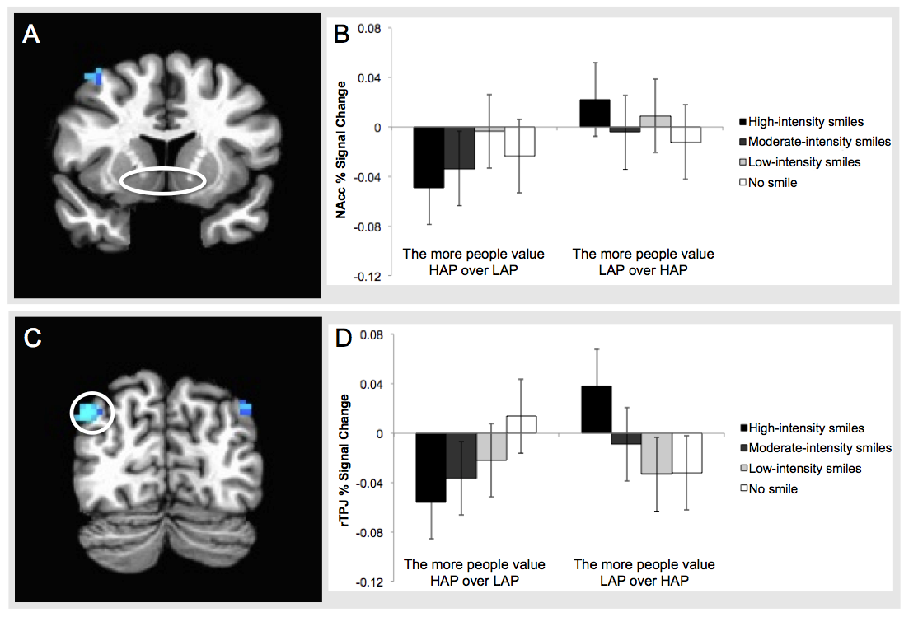
Fig S7. (A-B) Nucleus Accumbens (NAcc): Analyses revealed no significant interaction effect of Participant Ideal Affect (HAP – LAP) and Recipient Expression on NAcc activity. (C-D) Right temporo-parietal junction (rTPJ): Analyses revealed a significant interaction between Participant Ideal Affect (HAP – LAP) and Recipient Expression on rTPJ activity; the more participants valued high arousal positive states (HAP) over low arousal positive states (LAP), the lesser rTPJ activity they showed towards recipients with higher intensity smiles. The interaction between Participant Ideal Affect and Recipient Expression linear effect was significant, Effect (S.E.) = -.03 (.01), t(3394) = -2.45, p = .015, controlling for Participant Actual Affect (HAP – LAP). Although analyses were conducted on continuous Participant Ideal Affect (HAP – LAP) scores, results are plotted for ±2SD of Participant Ideal Affect (HAP – LAP) for presentative purposes. Warm colors indicate positive associations, while cool colors indicate negative associations. Thresholded at p < .005 uncorrected, cluster ≥ 11 continuous voxels, p < .05 corrected.
Section 8. Analyses Examining the Influence of Participant Actual Affect (HAP-LAP)
We examined the influence of the interaction between Participant Actual Affect (HAP – LAP) and Recipient Expression (excited, calm) on the offer amount, by running a Participant Actual Affect (HAP-LAP) X Recipient Expression (excited, calm) cumulative mixed model on the offer amount, controlling for Participant Ideal Affect (HAP-LAP) and treating participants as random effects. Overall, the more participants valued HAP over LAP, the less they offered to recipients, Estimate=-.51, S.E.=.25, z=-2.01, p=.044. Moreover, excited recipients received more money than calm recipients, Estimate=.29, S.E.=.04, z=7.84, p<.001. However, the main effect of Participant Actual Affect (HAP-LAP) was not significant, Estimate = -.20, S.E. = .28, z = -.71, p = .475, and neither was the interaction of Participant Actual Affect (HAP-LAP) by Recipient Expression (excited, calm), Estimate = .06, S.E. = .04, z = 1.25, p = .211.
Similarly, a Participant Actual Affect (HAP-LAP) X Recipient Expression (excited, calm) linear mixed-effects model on perceived trustworthiness, controlling for Participant Ideal Affect (HAP-LAP), with participants treated as random effects, revealed that excited recipients were rated as more trustworthy than calm recipients overall, Estimate = .15, S.E. = .02, t(3386) = 6.42, p < .001, 95% CI = [.10, .20]. There was no main effect of Participant Actual Affect (HAP-LAP), Estimate = -.05, S.E. = .14, t(33) = -.37, p = .717. There was a significant interaction of Participant Actual Affect (HAP-LAP) by Recipient Expression (excited, calm), Estimate = -.09, S.E. = .03, t(3386) = -3.03, p = .002, showing that participants who felt more HAP than LAP did not differentiate between excited recipients and calm recipients, Estimate = .06, S.E. = .05, t(3386) = 1.17, p = .242, 95% CI = [-.04, .15]. The more participants felt LAP over HAP, the more they perceived excited recipients as more trustworthy than calm recipients, Estimate = .31, S.E. = .05, t(3386) = 6.59, p < .001, 95% CI = [.22, .41], which was the opposite of the influence of ideal affect match.

Section 9. VOI analyses of dorsal medial prefrontal cortex activity
Coefficients from cumulative link mixed model examining whether dorsal medial prefrontal cortex (DMPFC) activity predicted subsequent offers, and coefficients from the linear mixed model testing whether this activity was modulated by ideal affect match. †p < .10, *p < .05
 | Coefficients (S.E.) predicting subsequent offers | Coefficients (S.E.) being modulated by ideal affect match
DMPFC | -.121 (0.060)* | -.024 (0.013)†

Section 10. Ideal affect match modulated Nucleus Accumbens (NAcc) activity during early face period (i.e., the first 2 s of the face viewing period)
Although we did not find an effect of ideal affect match on NAcc activity during the late face viewing period, we did find some evidence of an effect during the early face viewing period. We split participants into “Value HAP (high arousal positive)” and “Value LAP (low arousal positive)” groups, by assigning people whose Participant Ideal Affect (HAP – LAP) score was equal or higher than the median of Participant Ideal Affect (HAP – LAP) across all participants (Median = -0.50) to the “Value HAP” group, and assigning people whose Participant Ideal Affect (HAP – LAP) score was lower than the median of Participant Ideal Affect (HAP – LAP) to the “Value LAP” group. We then conducted a 2 Ideal Affect (Value HAP, Value LAP) X 2 Recipient Expression (excited, calm) linear mixed-effects model on NAcc activity at the first volume acquisition, i.e., when participants first viewed the recipient faces, with subjects as random effects. The Value HAP group showed a marginal increase in NAcc activity in response to excited versus calm recipients, Estimate for Difference (S.E.) = .02 (.01), t(3406) = 1.71, p = 0.088. †p < .10. 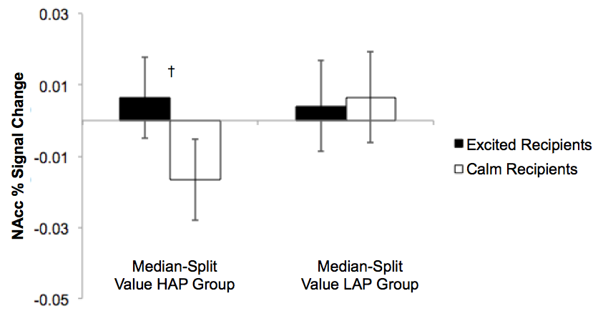
Section 11. Associations between trait ratings and brain activity during late face period

Nucleus Accumbens (NAcc) activity was not associated with any trait ratings except physical attractiveness. Right temporo-parietal junction (rTPJ) activity was selectively associated with trustworthiness ratings.
*p < .05, **p < .01.
 | Coefficients from  linear mixed model with NAcc | Coefficients from  linear mixed model with rTPJ
Friendliness | -.002 | -.005
Assertiveness | -.002 | .001
Dominance | .000 | .006
Financial Neediness | -.002 | .004
Intelligence | .003 | -.005
Physical attractiveness | .010** | -.002
Trustworthiness | -.001 | -.009*

Section 12. Reaction time for Study 2
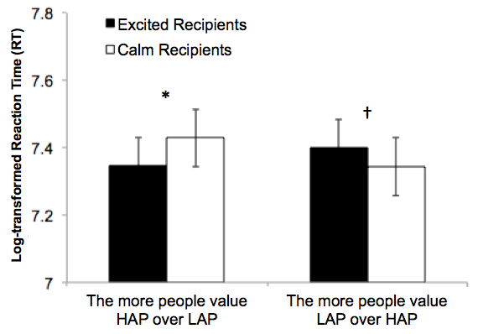
We log-transformed participants’ reaction time (RT) for each trial, to correct for the non-normal distribution of RT data (Banaji & Hardin, 1996). Analyses revealed a significant Participant Ideal Affect (HAP – LAP) by Recipient Expression interaction, Effect (S.E.) = -.02 (.01), t(3316) = -2.32, p = 0.021 for reaction time. The more participants valued HAP over LAP, the faster they made their choices in response to excited vs. calm recipients, Estimate (S.E.) = -.04 (.02), t(3316) = -2.46, p = .014. The more participants valued LAP over HAP, the faster they made their choices in response to calm vs. excited recipients, Estimate (S.E.) = .028 (.02), t(3316) = 1.68, p = 0.092, although this difference approached significance. We found the same pattern when using raw reaction time scores. *p < .05, †p < .10. Although analyses were conducted on continuous Participant Ideal Affect (HAP – LAP) scores, results are plotted for ±2SD of Participant Ideal Affect (HAP – LAP) for presentation purposes.

References
Banaji, M. R., & Hardin, C. D. (1996). Automatic Stereotyping. Psychological Science, 7(3), 136–141. http://doi.org/10.1111/j.1467-9280.1996.tb00346.x
Barrett, L. F., & Bliss-Moreau, E. (2009). She’s emotional. He’s having a bad day: attributional explanations for emotion stereotypes. Emotion, 9(5), 649–658. http://doi.org/10.1037/a0016821
Chen, L.-F., & Yen, Y.-S. (2007). Taiwanese Facial Expression Image Database. Brain Mapping Laboratory, Institute of Brain Science, National Yang-Ming University, Taipei, Taiwan.
Kemmelmeier, M. (2006). Individualism and Good Works: Cultural Variation in Giving and Volunteering Across the United States. Journal of Cross-Cultural Psychology, 37(3), 327–344. http://doi.org/10.1177/0022022106286927
Park, B., Tsai, J. L., Chim, L., Blevins, E., & Knutson, B. (2016). Neural evidence for cultural differences in the valuation of positive facial expressions. Social Cognitive and Affective Neuroscience, 11(2), 243–252. http://doi.org/10.1093/scan/nsv113
Preacher, K. J., & Hayes, A. F. (2008). Asymptotic and resampling strategies for assessing and comparing indirect effects in multiple mediator models. Behavior Research Methods, 40(3), 879–891. http://doi.org/10.3758/BRM.40.3.879

